
Village Surgery News
Summer 2026

BOWEL CANCER AWARENESS
Bowel cancer screening was introduced in the UK 20 years ago, and since then has saved thousands of lives

Bowel Cancer is the fourth most common cancer in the UK. About 43,000 people are diagnosed with bowel cancer each year. If it is detected early, treatment is more successful and there is a good chance of recovery.

If you are aged between 50 and 74 and receive a bowel screening kit (FIT), please provide the sample and post it back. This process takes minutes.

Don’t ignore it – it could be lifesaving

The following video provides a guide about how to complete and return your FIT kit. If you need any further advice or support, please let your doctor know so they can support you to get the right tests.
https://cancermatterswessex.nhs.uk/fit-test/

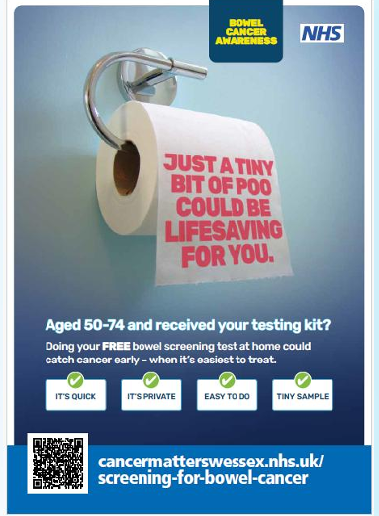

Benefits of using NHS App

- Order & track prescriptions
- View your GP health record.
- View hospital appointments
- Register your organ donation decision.
- Get health advice through 111 online.
- Book/amend/cancel vaccinations.
Getting started with the NHS App - NHS App help and support - NHS (www.nhs.uk)
Telephone: 01202 525252 www.villagesurgery.com


Travel Vaccines
If you require any vaccinations relating to foreign travel, you must complete the online or paper form and return to the surgery so that the practice nurse can determine what vaccines are required. It is important to complete these as early as possible, ideally 6+ weeks prior to travel. An appointment will be needed to administer any vaccines and should be at least 2 weeks before travelling. Some travel vaccines are not included in the service provided by the NHS and must be ordered on a private prescription. These will incur a charge over and above the usual prescription charge.
The questionnaire that must be completed and returned prior to your appointment can be found on the website or available at Reception.

Important Information for Students
If you are registered with us and are going home for the Easter/Summer breaks, please DO NOT re-register as a permanent patient unless you are not coming back to Bournemouth/Poole area.
If you do require treatment whilst not at university, you can register as a temporary patient at a local surgery.

Men’s Health Week 15th – 21st July
Focuses on raising awareness of men’s physical and mental health issues, encouraging check-ups, healthy lifestyle choices, and early detection.
LiveWell Dorset’s campaign “small changes can make a big difference” offers support in taking action

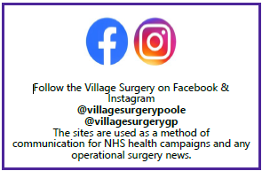
GP News
Dr Andrew Dickson joins the surgery this August

Bank Holiday Closure
Bank Holiday 31st August
“Ask Damian” is the new 24/7 Fraud Advice Service
It offers advice on all typers of fraud, aiming top spot scams early and encourages simple steps to avoid financial loss. It can also translate into different languages, making it accessible to a wide range of people.
In the last 13 months Dorset residents have lost £24.5million to fraud
Dorset Police 24/7 Fraud Advice Line 01202 144688
If you have been a victim of fraud, contact Report Fraud on 0300 123 2040



Help Dorset smokers make the Swap 2 Stop
Swap 2 Stop is a new nationwide campaign aimed at encouraging smokers to make the switch from smoking to vaping to improve their health. LiveWell Dorset is offering adult smokers who live in Dorset the opportunity to sign up for a free vape kit including six weeks’ worth of e-liquids, plus access to support via a downloadable quit app and online video coaching.
Nicotine vaping is now one of the most popular stop smoking aids. Studies show that when used alongside coaching support, it’s a very effective way of quitting. Smokers are addicted to nicotine, not tobacco. It is the tar and toxic chemicals in tobacco smoke that kills, so switching from smoking to vaping is a positive health move.
It’s an amazing offer for Dorset’s smokers and a chance to finally break free from tobacco and its toxic mix of more than 60 cancer-inducing chemicals.
Local smokers can sign up at www.livewelldorset.co.uk/swap-2-stop

Thank you to our Patient Participation Group for all their recent feedback. It is much appreciated.

Summer Holidays
For ideas on local activities please see links below
Family Information Directory (bcpcouncil.gov.uk)
Activity Finder | Active Dorset
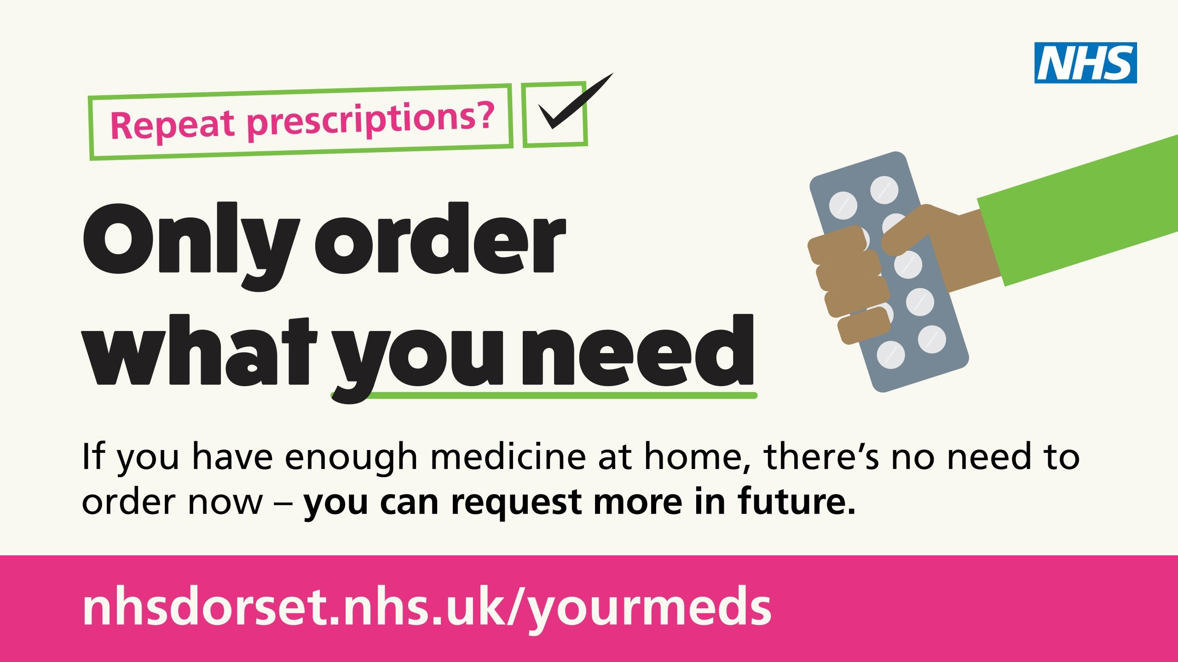
NHS Talking Therapies
The NHS is encouraging anyone struggling with feelings of depression, or anxiety such as excessive worry, panic attacks, social anxiety, post-traumatic stress, or obsessions and compulsions to seek help through NHS Talking Therapies services. These are effective, confidential and free treatments delivered by trained clinicians – online, on the phone, or on person.
You do not need to have a diagnosed mental health problem. Getting support as soon as you start having difficulties can help to reduce their impact.
Your GP can refer you for NHS Talking Therapies, or you can refer yourself online at nhs.uk/talk


